EE2080 : Microprocessor Systems Design and Interfacing
Design Project Report

Project Title : Design of a Gait and Vital Signs Monitoring System.
Submitted By: Chayan Deb.
Roll No. : 121801012.

Design Goal: The design goal for the project was given to be :
- Continuous heart rate monitoring.
- Continuous respiratory monitoring.
- Continuo gait monitoring.
- Processing of sensor data on FRDM KL25Z board.
- Display of heart rate, respiratory rate and Gait status on a workstation (mobile/laptop/cloud).
- An alert system for aiding the subject (e.g. Informing the subject to take rest). This could come from the workstation possibly aided by a clinician who is monitoring the status or automatically done within the processing chain.

Components Required: The list of components I have chosen for fulfilling this design goal is listed below :
- MAX30100 Pulse Oximeter and Heart-Rate Sensor (Communicates in I2C protocol).
- HC-05 Bluetooth module.
- FRDM KL25Z board.
- NXP MMA8451Q onboard 3-axis Accelerometer on the FRDM KL25Z board.

Interfacing Protocols: We are using the freedom board to interface with the sensors we using for monitoring and analysing the gait, heart rate and respiratory rate. The data transfer protocol for both the sensors we are using is Serial-I2C data transfer protocol.
This I2C data transfer protocol uses two wires to transmit data between devices. These two wires are called SCL (Serial Clock) and SDA (Serial Data). It is a synchronous mode of data transfer as one wire is dedicated for data transfer and another wire for agreeing on timing parameters.

The MAX30100 Pulse Oximeter and Heart-Rate Sensor uses two LEDs (one infrared and one red) to measure the Heart Rate and the SpO₂ levels in the blood respectively. For gait measurement, we are going to use the onboard 3-axis accelerometer as an IMU (Inertial Measurement Unit) and use the data to determine if the person is running and if yes, how many steps he has taken from a particular time instant. By using the inbuilt accelerometer sensor, we are eliminating additional sensor cost and making the system more portable and convenient. The Pulse Oximeter and Heart rate sensor we are using provides the measured data after processing it on the sensor itself. So, the design project now shrinks down to understanding and setting up the accelerometer sensor for gait measurement. This is achieved by using our FRDM KL25Z board’s internal ARM Cortex-M0+ processor for the data processing.
Finally, we will be using the HC-05 Bluetooth module to transfer the data to be displayed in the workstation. The HC-05 module uses the UART data transfer protocol.

Detailed Connection Diagram: We will use the PTC10 and PTC11 pins for the I2C data transfer protocol between the FRDM board and the MAX30100 sensor. Since the internal 3-axis accelerometer is internally connected to the PTE24 and PTE25 pins, there is no need of externally interfacing it with the board. Instead we can simply activate these ports and have the required data for further processing.
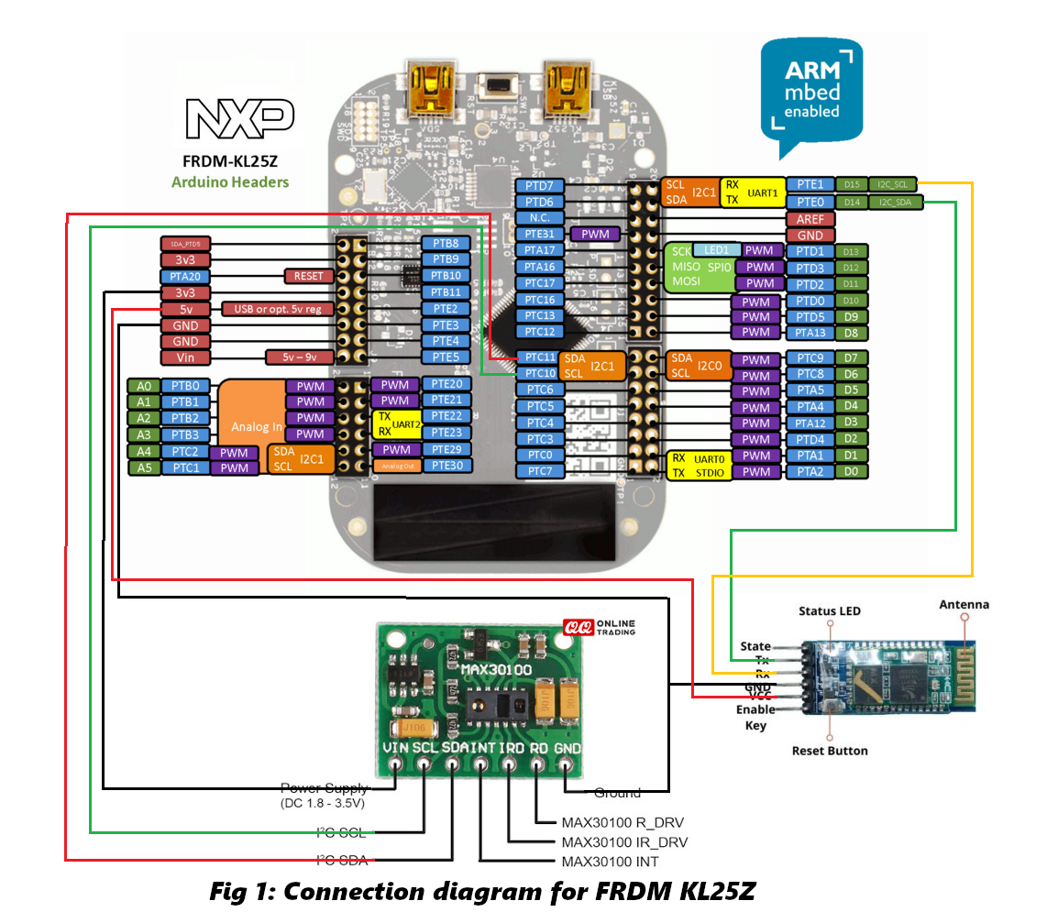
In the sensor module, the individual LED driver and the interrupt pins are unused. Finally, for the data to be streamed to the required workstation we need to use the UART data transfer protocol which can be accessed from PTE0 and PTE1 pins.

Overall Operation: The device collects the heart rate and the respiratory rate from the sensor itself and sends it over to the workstation using Bluetooth. Again, the onboard accelerometer sensor data is read and processed using the board’s powerful ARM Cortex-M0+ processor. Now the processed data is used to monitor gait and the data is sent over to the workstation via Bluetooth.
The pseudo-code for operating the device is written below :

int init_pins(void){
enable_clock(port_C);
multiplex_to_I2C_SCL(port_C10);
multiplex_to_I2C_SDA(port_C11);
multiplex_to_UART_RX(port_E1);
multiplex_to_UART_TX(port_E0);

enable_clock(port_E);
multiplex_to_I2C_SCL(port_E24);
multiplex_to_I2C_SDA(port_E25);
return 0;
}

int main(){
init_pins();
x_data = [];
y_data = [];
z_data = [];
while(1){
for(1_sec_delay){
acc_x = read_accelerometer_x(port_E24, port_E25);
acc_y = read_accelerometer_y(port_E24, port_E25);
acc_z = read_accelerometer_z(port_E24, port_E25);
x_data.push(acc_x);
y_data.push(acc_y);
z_data.push(acc_z);
}
gait_data = analyze_data_and_count_steps(x_data, y_data, z_data);
heart_rate, Sp02_level = read_data(port_C10, port_C11);
send_data_via_BT(heart_rate, Sp02_level, gait_data);
check_for_pause_signal(port_E0, port_E1);
}
return 0;
}

Estimated Total Cost: The cost of the HC-05 Bluetooth module is INR 450, the FRDM KL25Z development board costs ~INR 1200 and the MAX30100 costs INR 466.
This makes the device’s total cost of building approximately INR 2200.

